How to switch ink types

- Switching between Ink types via “chip trouble”

First create a new ULK file set the status in ACG on “chip trouble”.
Example for XPJ-1682SR:
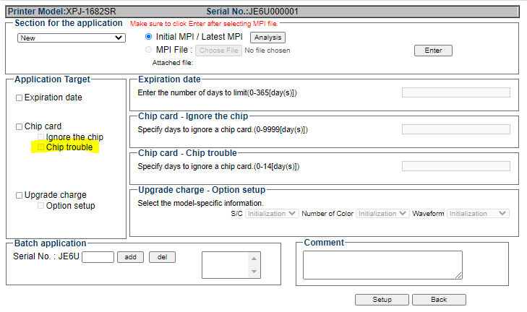

In this set-up the ink type can be changed in Diagnostics mode (Parameter update/Ink type)
See workflow as illustrated hereunder.
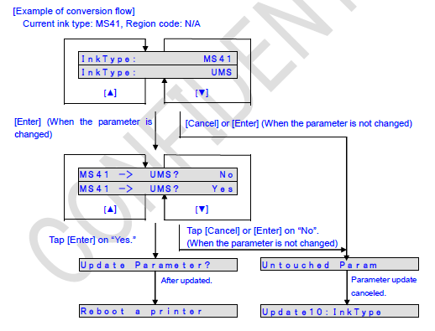

Once the ink conversion has been finished, the printer will request a reboot. By doing so the “chip trouble” status will be automatically disabled and the printer will have been switched to the new ink type.

This feature is currently present in following:
- VJ-1638UH/UH2: 1.15
- VJ-1638UR/UR2: 1.08
- XPJ-1641SR: 1.04
- XPJ-1682SR: 1.05
- XPJ-461UF: 1.02
- XPJ-661UF: 1.02
- XPJ-1642WR: 1.05 (to set in DS3)
- XPJ-1682WR: 2.02 (to set in DS3)
- XPJ-1641SR-P: MS41 and UMS (FW1.03)

- VJ-1638UR switch to UH21
In some cases the VJ-1638UR needs to be set in rigid (UH21) ink type (Ex SmartColor).
Workflow:
- New installation (no ink loaded yet):
  - Update to FW1.07 or higher
  - Make a new ULK file with the “test function 1” active
  - Install UH21 ink

- Already loaded with US11:
  - Update to FW1.07 or higher
  - Make a new ULK file with the “test function 1” active
  - Wash the ink channels in self diagnosis mode by using cleaning liquid
  - Install ULK file
  - Install UH21 ink

- VJ-1638UH(2) / UR(2) set in or switch to UA31

General: In order for these models to accept the UA31 chips the region code must be set to “MEN UA31” and the ink kind must be changed in Diagnostics mode. At that time only UA31 is accepted.
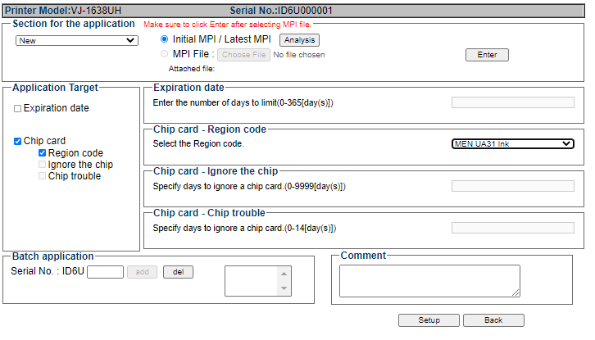

1/ Installation of a new unit:
FW1.16 for VJ-1638UH2; FW 1.09 for VJ-1638UR2
Factory Default
↓
Change Region Code Setting to: MEN UA31
↓
UH22-CL Initial Wash
↓
UA31 Ink Load | The ink type and number of colors are determined according to the S/C card information.
↓
Ready to Print

2/ Ink switch on an existing printer
a/ Switching from US11 to UA31 (liquids are compatible)
- Load correct FW
- Perform “ink discharge”
- Set region code in “MEN UA31” via MPI/ULK
- Switch ink type in Diagnostics mode while unit is in “chip trouble” (MPI/ULK)
- To see the Ink type “UA31”, the cartridges (with chips) must be loaded.
- Ink load with UA31
b/ Switching from UH21 to UA31 (liquids are not compatible)
- Load correct FW
- Perform “Long store” with UH22 cleaning
- Set region code in “MEN UA31” via MPI/ULK
- Switch ink type in Diagnostics mode while unit is in “chip trouble” (MPI/ULK)
- To see the Ink type “UA31”, the cartridges (with chips) must be loaded.
- Ink load with UA31
b/ Switching back from UA31 to UH21 (liquids not compatible)
- Load correct FW
- Perform “Long store” with UA31 cleaning
- Uncheck the UA31 region code (MPI).
- Wash the printer with UH22-CL
- Ink load with UH21
- (if needed : “chip trouble” to be able to choose ink type)

b/ Switching from UA31 to US11 (liquids compatible)
- Load correct FW
- Ink discharge
- Uncheck the UA31 region code (MPI).
- Ink load with US11
- (if needed : “chip trouble” to be able to choose ink type)

- Set unchipped XPJ-WB in “DS3-chipmodus”
Machine which is already running unchipped on DS3 ink:
- Upgrade to 1.05 (XPJ-1642WR) / 2.02 (XPJ-1682WR) (if needed)
- Receive MPI from customer and set Region code to DS3 (via ACG)
- Return ULK to customer
- Load ULK on printer
- Receive fresh MPI from customer and set the chips inactive via “Chip trouble” on 1 (or 2, or more) days).
- Return ULK to customer
- Load ULK on printer
- In diagnostics mode “parameter/update/ink kind” choose DS3.
- After message: “reboot a printer” power off unit and restart in user mode.
- Unit will accept as of now DS3 chips.

Machine which is unchipped at MEN, but not activated (used) yet:
- Upgrade to 1.05 (XPJ-1642WR) / 2.02 (XPJ-1682WR) (if needed)
- Receive MPI from customer and set the chips active (ACG)
- Return ULK to customer
- Load ULK on printer
- Receive new MPI from customer and set Region code to DS3 (via ACG)
- Return ULK to customer
- Load ULK on printer
- Unit will accept as of now DS3 chips.

- To set a unit back to “original status”, you need to do following:
- Uncheck the DS3 region code (MPI-ULK)
- Unchip the printer (via second MPI-ULK transaction).
- Then you can choose the Inktype as follows:

